Indian agricultural crop production Analysis (1997 – 2021)

**INTRODUCTION**

Crop production is a common agricultural practice followed by worldwide farmers to grow and produce crops to use as food and fiber. This practice includes all the feed sources that are required to maintain and produce crops.

India is one of the largest producers of agriculture production in the world. It is the second largest producer

in the wheat and rice. Wheat cultivation in India traditionally been dominated by the northern region of India. The

northern states of Punjab and Haryana Plains in India have been prolific wheat producers. While this cereal grass has

been studied carefully in the past, recent years of painstaking research by India's finest scientific talent has paid off

with the development of distinctly superior varieties of Durum Wheat.

India is one of the largest producers of agriculture production in the world. It is the second largest producer

in the wheat and rice. Wheat cultivation in India traditionally been dominated by the northern region of India. The

northern states of Punjab and Haryana Plains in India have been prolific wheat producers. While this cereal grass has

been studied carefully in the past, recent years of painstaking research by India's finest scientific talent has paid off

with the development of distinctly superior varieties of Durum Wheat.

India is one of the largest producers of agriculture production in the world. It is the second largest producer

in the wheat and rice. Wheat cultivation in India traditionally been dominated by the northern region of India. The

northern states of Punjab and Haryana Plains in India have been prolific wheat producers. While this cereal grass has

been studied carefully in the past, recent years of painstaking research by India's finest scientific talent has paid off

with the development of distinctly superior varieties of Durum Wheat.

**OVERVIEW**

* Agriculture is an evolutionary process that consists of a series of activities such as the production of food, fibers, feed, and raising of domesticated animals to fulfill the demand of the population. Agriculture is a key to development in the area of human civilization.
* Smart farming provides farmers with real-time data and insights into their farming practices. This data can be used to make informed decisions about inputs, planting schedules, and other factors that can impact crop yields.

INTRODUCTION

India is one of the largest producers of agriculture production in the world. It is the second largest producer

in the wheat and rice. Wheat cultivation in India traditionally been dominated by the northern region of India. The

northern states of Punjab and Haryana Plains in India have been prolific wheat producers. While this cereal grass has

been studied carefully in the past, recent years of painstaking research by India's finest scientific talent has paid off

with the development of distinctly superior varieties of Durum Wheat.

2.HYPOTHESIS OF THE STUDY

India is one of the largest producers of wheat in the world but compare to production of wheat India is not as

much large exporter.

3.OBJECTIVE OF THE STUDY

The primary objective of this study is as given below

1.To study the Indian agricultural crop production i.e. wheat

2.To study the Indian export of agriculture crop wheat

1 2

Limbore Nilesh V. and Khillare Shrirang K. ,“AN ANALYTICAL STUDY OF INDIAN AGRICULTURE CROP

INTRODUCTION

India is one of the largest producers of agriculture production in the world. It is the second largest producer

in the wheat and rice. Wheat cultivation in India traditionally been dominated by the northern region of India. The

northern states of Punjab and Haryana Plains in India have been prolific wheat producers. While this cereal grass has

been studied carefully in the past, recent years of painstaking research by India's finest scientific talent has paid off

with the development of distinctly superior varieties of Durum Wheat.

2.HYPOTHESIS OF THE STUDY

India is one of the largest producers of wheat in the world but compare to production of wheat India is not as

much large exporter.

3.OBJECTIVE OF THE STUDY

The primary objective of this study is as given below

1.To study the Indian agricultural crop production i.e. wheat

2.To study the Indian export of agriculture crop wheat

1 2

Limbore Nilesh V. and Khillare Shrirang K. ,“AN ANALYTICAL STUDY OF INDIAN AGRICULTURE

India is one of the largest producers of agriculture production in the world. It is the second largest producer

in the wheat and rice. Wheat cultivation in India traditionally been dominated by the northern region of India. The

northern states of Punjab and Haryana Plains in India have been prolific wheat producers. While this cereal grass has

been studied carefully in the past, recent years of painstaking research by India's finest scientific talent has paid off

with the development of distinctly superior varieties of Durum Wheat.

2.HYPOTHESIS OF THE STUDY

India is one of the largest producers of wheat in the world but compare to production of wheat India is not as

much large exporter.

3.OBJECTIVE OF THE STUDY

The primary objective of this study is as given below

1.To study the Indian agricultural crop production i.e. wheat

2.To study the Indian export of agriculture crop wheat

1 2

Limbore Nilesh V. and Khillare Shrirang K. ,“AN ANALYTICAL STUDY OF INDIAN AGRICULTURE CROP

INTRODUCTION

India is one of the largest producers of agriculture production in the world. It is the second largest producer

in the wheat and rice. Wheat cultivation in India traditionally been dominated by the northern region of India. The

northern states of Punjab and Haryana Plains in India have been prolific wheat producers. While this cereal grass has

been studied carefully in the past, recent years of painstaking research by India's finest scientific talent has paid off

with the development of distinctly superior varieties of Durum Wheat.

2.HYPOTHESIS OF THE STUDY

India is one of the largest producers of wheat in the world but compare to production of wheat India is not as

much large exporter.

3.OBJECTIVE OF THE STUDY

The primary objective of this study is as given below

1.To study the Indian agricultural crop production i.e. wheat

2.To study the Indian export of agriculture crop wheat

1 2

Limbore Nilesh V. and Khillare Shrirang K. ,“AN ANALYTICAL STUDY OF INDIAN AGRICULTURE CROP

# Role of Agriculture in Indian Economy

Agriculture is the foundation of the Indian economy. The population of India mostly depends on agriculture for their livelihood and agriculture contributes to 40 percent of the total GDP of the country. While agriculture is one of the most important sectors, it has taken a comparative backseat and the service sector is leading the way.

**Advantages**

**1. Natural Environment**

Organic farming usually goes down in a natural environment. Unnecessary enclosures are not used for the crops or plants. This way the productivity is increased and is way better compared to closed spaces. An open and natural area for growing the crops would give them wild and instinctive growing nature. This is ideal for the crops and is one of the factors that leads to the plants being organic.

**2. No Chemicals**

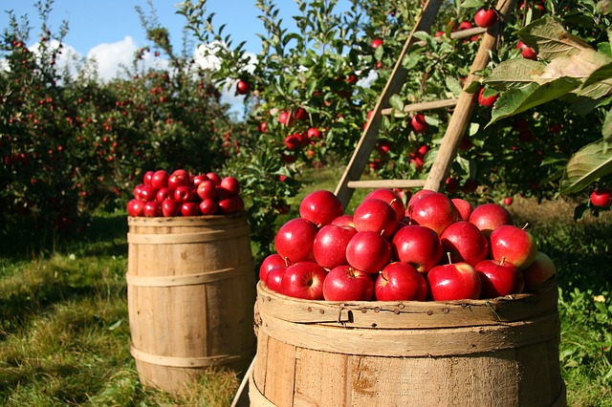

Unlike other forms of farming, organic farming does not involve any artificial sources like chemicals to drive away pests or to speed up the process of farming. These chemicals are often used in commercial and industrial farming methods. However, organic farming stays true to its title. Its method is true to its natural core and does not use anything that may be of harm to its consumers. Any type of chemical is not entertained in the organic farming industry.

**3. Eye On You**

Unlike any other procedure, organic farming has a very strict supervision schedule. The reason for this extreme regulation is because of the importance to keep the label organic. It is very difficult to do so as most brands use artificial aspects in their farming. There are various **methods of organic farming** and its standards must be maintained in order to remain organic. This ensures that customers buying the end product receive what they’re truly looking for.

**4. Environmentally Friendly**

Among the **advantages of organic farming**, this one stands out the most. Today, almost the entire sector of industrial farming consists of chemicals that ruin the environment. However, when you have something like organic farming to replace it, a huge benefit is received. Organic farming does not use any form of chemical nor does any form of pollution happen because of it. This makes it way better than regular farming. The whole world suffers because of the ignorant methods of regular farming including animals. Organic farming is definitely the way to go.

**5. Healthier And Tastier**

Since non-organic farming produces results that are way too suspicious when eaten, it is obvious that it isn’t good for health either. **Organic farming in kerala** for example are known to keep the crops growing properly. They are given time and care unlike non-organic sectors that pump the results with chemicals in order for it to grow faster. These type of sectors are only commercial-minded and are least bothered about the satisfaction and health of the consumer. Since the fruits and vegetables grown organically are given longer time to flourish, they automatically are way better in terms of nutrition and taste.

**Disadvantages**

**1. Expensive Products**

One of the major problems of organic farming methods is that sometimes it can get a bit costly. Some products related to organic farming are too expensive, leading to some common people to not be able to afford it. In a country like India where most of its livelihood are farmers, organic farming brings a huge problem to it. However, **organic farming in Tamil Nadu** have had some success stories.

**2. More Labor**

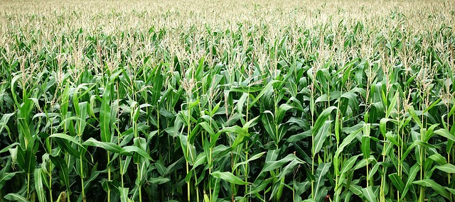

Organic farming is a sector that requires a lot of patience. This is because pests and others obstacles must be tackled manually. Unlike in non-organic farming, the use of pesticides and other chemicals are not permitted. This makes the work of the farmer harder as constant attention and care is needed. Due to the constant attention, a lot of time is consumed. Organic farming has to be executed well which needs a lot of time and not to forget weed-prevention.

**3. High MRP**

It is almost obvious that due to the extreme care taken to go along with organic farming, the results would be kept at a high price. Once sold to the market, most of the place is devoted to the sale of these organic fruits and vegetables. Most people do that approve of organic products because of this. The items sold in the market are half the price of non-organic products. So, we can say that organic items are expensive and not every consumer is willing to pay the price for it.

**4. Cross Breeding Problem**

The seeds of GMO plants once planted, create GMO crops. These crops then produce seeds and the pattern continues. This makes it very difficult to tell from the organic and GMO crops. This has become a huge problem in the organic farming sector. This could ruin the future of organic planting as a whole.

**5. Labor Charges**

Labor charges refer to the amount payable to someone who has been involved in the building ot working of something.  Like we said earlier, in organic farming ventures, the amount of labor is high and it takes a lot of time and patience to the get work done. If one is not able to do it by oneself, a lot of labor would be hired which increases the payment that those laborers deserve.

However, people are starting to prefer organic farming and are performing such practises like – [mushroom cultivation](http://www.akmindia.in/mushroom-cultivation/), aloe vera farming, [spirulina cultivation](http://www.akmindia.in/spirulina-cultivation/), [sugarcane cultivation](http://www.akmindia.in/sugarcane-cultivation/), [banana cultivation](http://www.akmindia.in/banana-cultivation/), [pomegranate cultivation](http://www.akmindia.in/pomegranate-cultivation/) etc. in various parts of our country.

**Conclusion**

The Indian economy is an agro-economy and depends highly on the agricultural sector. Despite just supporting the Indian Economy, the agricultural sector also supports the industrial sector and international trade in imports and exports.